Davidson County
Youth Soccer League
Presents
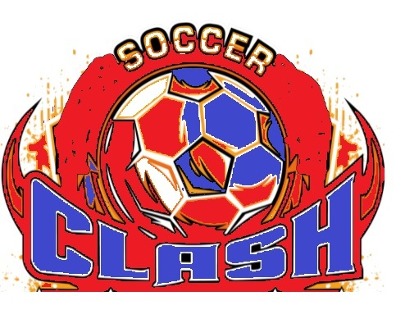

Become a sponsor Davidson County Youth Soccer Association’s November Clash Tournament. It is held this year at Denton Elementary Soccer fields starting November 7 and championship day on the 11th. Show your support for our community youth soccer teams by becoming a sponsor. For only $50.00, your business or organization name will appear on the back of the official November Clash Soccer
Tournament T-shirts. You'll also receive a shirt for being a sponsor!

Community Represented:
Board Member's name:
T-shirt size for the sponsor:

Business Information:
(or attach a business card) Name of the business: Address:
Email:
Phone Number:

